**REPORT**

By:

Piyush Bansal

**Introduction**

After going through all the data of Survey, I encountered a lot of dilemmas over certain question. So, here I tried to give answers of these question.

So, my first question is.

**What Is The Age Of Enrolled Survey Participants In Udacity??**

|  |  |
| --- | --- |
| Measure | Value |
| mean | 33.91691 |
| median | 32.83151 |
| Mode | 37.80822 |
| Std_Dev | 9.688868 |
| Range | 78 |

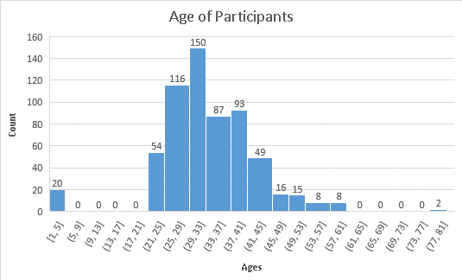

Here, we can see that mostly students are in range of (29,33) years that are enrolled in udacity. Their mean age is around 34 years and median is 33 around which means mostly 33 years students are interested to learn from udacity , so udacity should make their content for these age groups. Maximum number of students is of 38 years which are interested to learn from Udacity. As Std_Dev is around 10 years, we can analyze that students from 24 to 44 years is best group of best that want to learn.

*Result are Limited to Survey Participants

My 2nd question is:

**What was most helpful when students got stuck in the Nanodegree program(s)?**

As I am also doing my nanodegree program, so I find myself as a right person to answer this question. If I go with the facts, it says forums are the most helpful and live help the least. And it is right to say because, it has some genuine question and answers which is relevant to our nanodegree.

The slack is found to be 2nd useful platform followed by stack overflow and if I am not wrong AMA sessions do not help much in our nanodegree course.

My 3rd ques is: This was to see the current trend in nanodegrees.

**What are some of the Nanodegree program that the Students are interested in?**

|  |  |
| --- | --- |
| **Nanodegrees** | **Count** |
| Intro To Programming | 23 |
| Business Analyst | 19 |
| Data Analyst | 157 |
| Machine Learning | 235 |
| Artificial Intelligence | 111 |
| Deep Learning | 291 |
| Self Driving Car | 15 |
| Robotics | 8 |

Here I found that students are mostly interested in Deep Learning Foundation. As our current trend is moving towards Artificial intelligence, Students found Deep Learning to be an important learning tool before learning Artificial Intelligence.

More than 50% students are interested in Machine Learning, Artificial Intelligence and Deep learning Foundation due to the current trend in our Industry.

Students are least interested in Robotics and have little bit more in Self Driving Cars , this may be due to students find more interest in coding rather than doing both hardware and coding .

So, my last question is:

**After completing their Respective Education, How many Years of Experience People are willing to take the Nanodegrees???**

|  |  |  |
| --- | --- | --- |
| What is your highest level of education? | Years of experience in Job | Count of People |
| Associates | 117 | 12 |
| Bachelors | 1552 | 283 |
| High school or below | 120 | 24 |
| Masters | 2332 | 316 |
| Nanodegree Program | 249 | 45 |
| PhD | 602 | 73 |

So, mostly bachelors are willing to take the nanodegrees with more 1500 years of cumulative experience. Experience of each bachelor will be around 5-6years.

And the least wiliness are shown by associates with an average experience of 9-10 years. And those who’s all passed through the Nanodegrees are also great in number to join new nanodegrees to uplift more in their career.

**Analysis**

After all this analysis, Mostly people are from Argentina that want to enroll in Nanodegrees with an age group of 29 to 33 years and I hope Udacity will improve their forum platform more so as to remain always helpful for students and Lastly, Deep Learning Foundation is most Loved Nanodegree by the people.